

Semester Two Examination, 2024
Question/Answer booklet

MATHEMATICS
METHODS
UNITS 3&4

If required by your examination administrator, please place your student identification label in this box
Section One:
Calculator-free
WA student number: In figures

In words

Your name

Number of additional
answer booklets used
(if applicable):

Time allowed for this section
Reading time before commencing work: five minutes
Working time: fifty minutes

Materials required/recommended for this section
To be provided by the supervisor
This Question/Answer booklet
Formula sheet

To be provided by the candidate
Standard items: pens (blue/black preferred), pencils (including coloured), sharpener,
correction fluid/tape, eraser, ruler, highlighters

Special items: nil

Important note to candidates
No other items may be taken into the examination room. It is your responsibility to ensure that you do not have any unauthorised material. If you have any unauthorised material with you, hand it to the supervisor before reading any further.

Structure of this paper

Section | Number of  questions  available | Number of  questions to  be answered | Working  time  (minutes) | Marks  available | Percentage  of  examination
Section One:  Calculator-free | 7 | 7 | 50 | 52 | 35
Section Two:  Calculator-assumed | 10 | 10 | 100 | 97 | 65
 |  |  |  | Total | 100

Instructions to candidates

1. The rules for the conduct of examinations are detailed in the school handbook. Sitting this examination implies that you agree to abide by these rules.

2. Write your answers in this Question/Answer booklet preferably using a blue/black pen.
Do not use erasable or gel pens.

3. You must be careful to confine your answers to the specific question asked and to follow any instructions that are specific to a particular question.

4. Show all your working clearly. Your working should be in sufficient detail to allow your answers to be checked readily and for marks to be awarded for reasoning. Incorrect answers given without supporting reasoning cannot be allocated any marks. For any question or part question worth more than two marks, valid working or justification is required to receive full marks. If you repeat any question, ensure that you cancel the answer you do not wish to have marked.

5. It is recommended that you do not use pencil, except in diagrams.

6. Supplementary pages for planning/continuing your answers to questions are provided at the end of this Question/Answer booklet. If you use these pages to continue an answer, indicate at the original answer where the answer is continued, i.e. give the page number.

7. The Formula sheet is not to be handed in with your Question/Answer booklet.
Section One: Calculator-free 35% (52 Marks)
This section has seven questions. Answer all questions. Write your answers in the spaces provided.

Working time: 50 minutes.

Question 1 (7 marks)
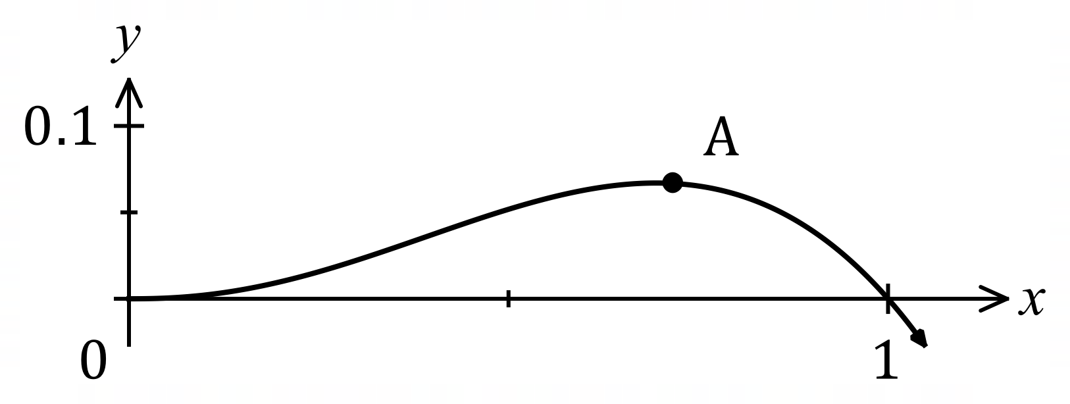
The graph of $y=f(x)$ is shown,
where $f\left(x\right)=x^{2}\left(\sqrt{x}-x\right)$.

(a) Determine the $x$-coordinate of the stationary point marked $A$ in the graph. (4 marks)

(b) Determine the area between the curve and the $x$-axis between $x=0$ and $x=1$.
(3 marks)

Question 2 (8 marks)
Determine the following:

(a) $\int{\underset{ }{6\cos\left(2x+3\right)}}dx$. (2 marks)

(b) $\int_{0}^{3}{\begin{matrix}d \\ \overline{dx}\end{matrix}\left(\sin\left(\begin{matrix}πx \\ \overline{ 4 }\end{matrix}\right)\right) }dx$. (2 marks)

(c) $\int_{1}^{4}{\underset{ }{\sqrt{3x-3}}}dx$. (2 marks)

(d) $\begin{matrix}d \\ \overline{dy}\end{matrix}\int_{y}^{1}{(2-\underset{ }{e^{π-4x})}}dx$. (2 marks)

Question 3 (8 marks)
(a) Express using natural logarithms the $x$-coordinate of the point where the curve $y=5^{-x}$ intersects with the curve $y=3^{1-2x}$. (3 marks)

(b) Given that $f(x)$ has domain $x>-5$, has derivative $f^{'}\left(x\right)=\begin{matrix}1 \\ \overline{x+5}\end{matrix}$, and the curve $y=f(x)$ passes through the point $(-4, 7)$, determine an expression for $f(x)$. (2 marks)

(c) Solve the equation $\ln{(x+3)}-2=\ln{x}$. (3 marks)

Question 4 (7 marks)
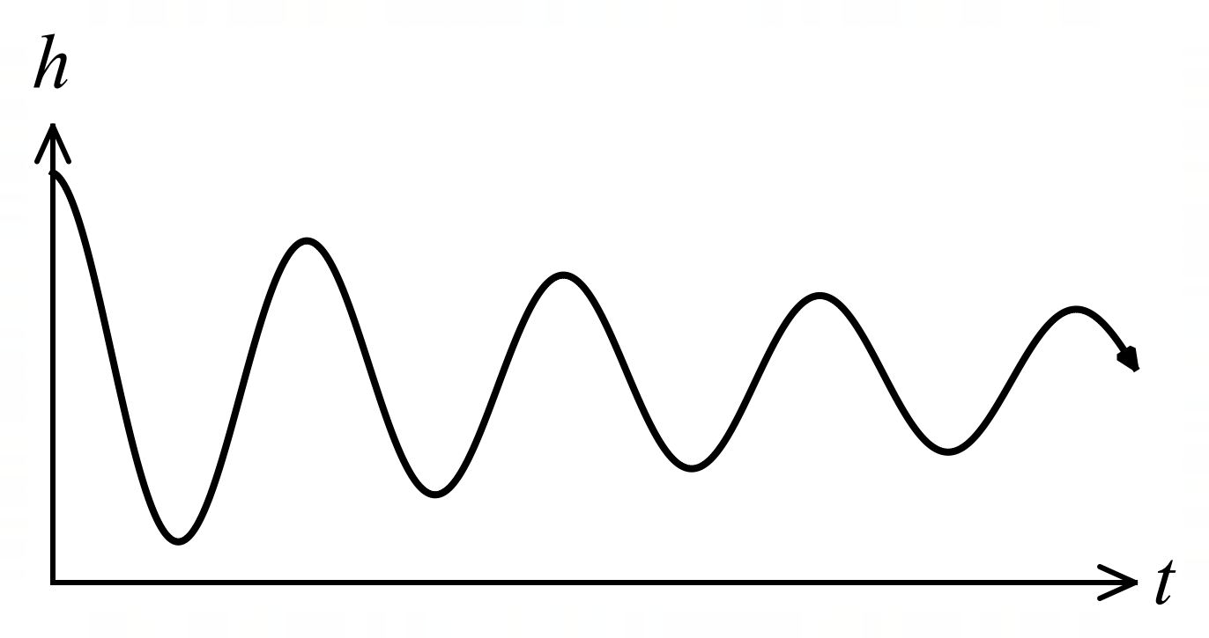
The graph shows the height $h$ cm of
a small mass suspended by a spring
above a bench top $t$ seconds after it
was released, where
$$h=3+\frac{3\cos\left(4πt\right)}{t+1}.$$

(a) Calculate the height of the mass when $t=1$. (1 mark)

(b) Determine the rate of change of height of the mass when $t=1$. (3 marks)

(c) Use the increments formula to estimate the height of the mass when $t=1.1$. (3 marks)

Question 5 (8 marks)
A curve passes through the point $(0, -2)$ and is such that $\begin{matrix}dy \\ \overline{\overset{ }{dx}}\end{matrix}=e^{3x}-3e^{-2x}$.

(a) Determine the equation of the curve. (3 marks)

(b) Show that the curve is always concave up. (2 marks)

(c) Determine the $x$-coordinate and nature of the stationary point of the curve. (3 marks)

Question 6 (7 marks)
The excess length $X$ m of a roll of cable is a continuous random variable whose probability density function is shown below.
$$f\left(x\right)=\left\{ \begin{matrix}\frac{k}{2x+1} & 0≤x≤3 \\ 0 & \text{otherwise.}\end{matrix}\right.$$

(a) Show that the constant $k=\begin{matrix}2 \\ \overline{\ln{7}}\end{matrix}$. (4 marks)

The cumulative distribution function of $X$ is shown below.

$$P\left(X≤x\right)=\left\{\begin{matrix}0 & x<0 \\ g(x) & 0≤x≤3 \\ 1 & x>3\end{matrix}\right.$$

(b) Determine an expression for $g(x)$. (2 marks)

(c) Determine the probability that the excess length is no more than $2.5$ m. (1 mark)

Question 7 (7 marks)
(a) The function $f\left(x\right)={\left(\ln\left(\begin{matrix}x \\ \overline{2}\end{matrix}\right)\right)}^{2}+a\ln\left(\begin{matrix}x \\ \overline{2}\end{matrix}\right)+b$ has a local minimum at $\left(2e^{-4}, -5\right)$. Determine the value of the constant $a$ and the value of the constant $b$. (4 marks)

(b) Solve the simultaneous equations $\log_{6}{x}+\log_{6}{y}=2$ and $\log_{6}{x^{2}}-\log_{6}{y^{4}}=1$ for $x$
and $y$. (3 marks)

Supplementary page

Question number: _________

Supplementary page

Question number: _________

© 2024 WA Exam Papers. Leeming Senior High School has a non-exclusive licence to copy and communicate this document for non-commercial, educational use within the school. No other copying, communication or use is permitted without the express written permission of WA Exam Papers. SN056-245-1.

